OBJECTIVE QUESTIONS

Question 1
What is the total no. of tables present in the data?

Solution:

Final Answer:
Basically, the data sheet contains only one table.

Approach:
Because there we no any other spreadsheet in the raw data excel sheet.

Question 2
What is the total no. of attributes present in the data?

Solution:

Final Answer:
Attributes refers to a no of columns that is 35
Approach:
By simply I can calculate the no of columns by selecting the row 1 with headers.
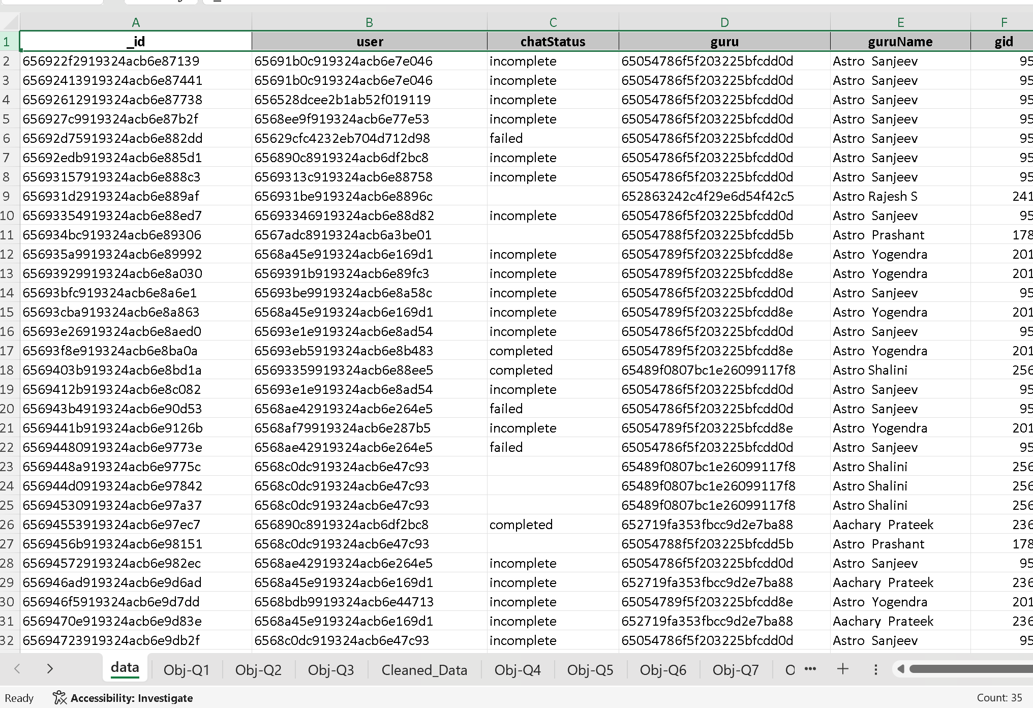 By seeing at the right bottom of the sheet.

Question 3
The data consists of some inconsistent and missing values so ensure that the data used for further analysis is cleaned.

Solution:

Final Answer:
Copy the raw data and applied this approach to get the cleand_data sheet.

Approach:
Understanding the Data
Handling Missing Data and filling with average/ mean values and categorical data also.
Removal of Duplicate Records
Date and Time Formatting
Removing unnecessary columns with large data values missing.
Final Data Verification
Saving the Cleaned Dataset.

Question 4
What is the change in daily call volume day by day and also find the average daily call volume.

Solution:
To answer this question I have followed step by step by process
Selected unique dates
Extracted unique values from the Date column using the UNIQUE() function.
Calculated daily call volume
Used the CallSid column to count the number of calls on each day (non-blank CallSid values indicate valid calls).
Computed average daily call volume
Applied the AVERAGE() function to the daily call counts to get the mean volume of calls per day.
Calculated daily change in call volume
Used a formula like =CurrentDayVolume - PreviousDayVolume to compute the day-over-day change in call volume.
Observations:
The daily call volume fluctuates significantly from one day to the next.
There are several sharp spikes and drops, indicating irregular call traffic (e.g., big spike on Day 9, sudden dip on Day 11).
This pattern shows high volatility, possibly due to changes in user behaviour, campaign activity, or external events.
The average change in daily call volume is approximately 246 calls, showing large day-to-day variability.
No clear trend of increase or decrease the changes are erratic, not progressive

The charts include from the excel sheet.

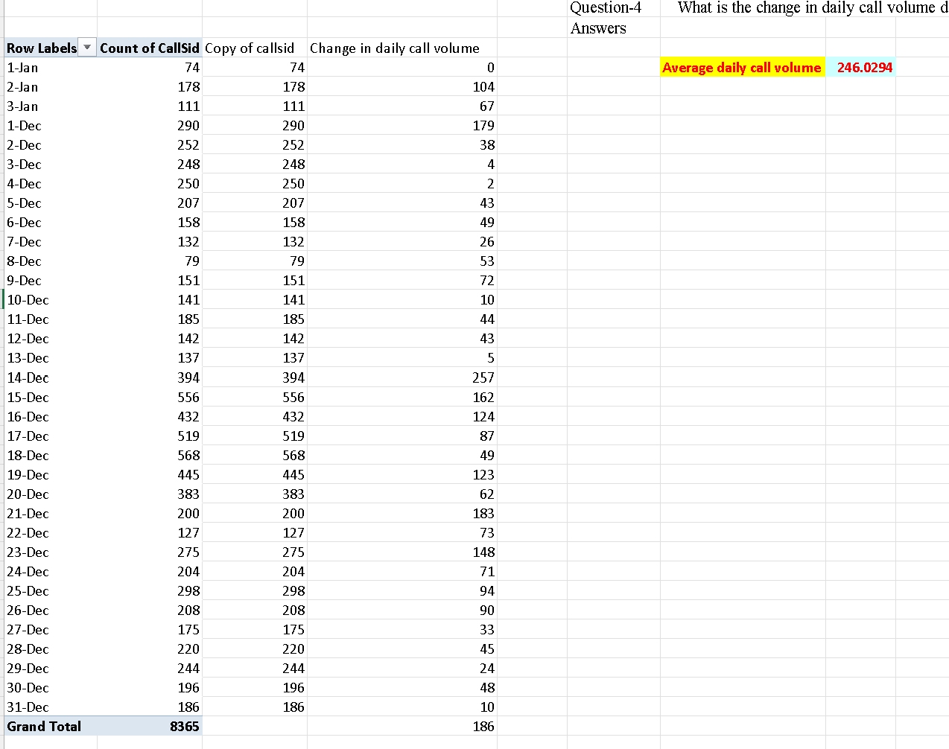

Question 5
Which months experienced the highest and lowest call volumes?

Solution:

Final Answer:
So, from the pivot table we can see Jan month experienced the lowest call and Dec experienced the highest call.

Approach:
Using pivot table I simply added createdAt in rows grouped by the months and with _id I get the count of call volume in each month.

Charts & Tables (if any):

Table describes the call volume by the Jan and Dec month.

Question 6
What is the total operational cost for that month?
Solution:

Final Answer:
From pivot table we can see the operational cost for both months.

Approach:
Using pivot table I simply added createdAt in rows grouped by the months and to calculate the operational cost Operational cost = the money the company spends to run its operations for that month. And with astrologer’s earnings we can say how much company did pay the cost of their operations.
Charts & Tables (if any):
Row Labels | Sum of astrologersEarnings
Jan | 5360.408
Dec | 93786.16295
Grand Total | 99146.57095
- Description:
Month and the astrologer’s earnings.

Question 7
What is the average number of calls handled per agent per day?
Solution:

Final Answer:
Approach:
- Total Number of Calls:
Created a Pivot Table by filtering consultation type = "Call" and using the callstatus column in the Values section to count total calls.
- Total Number of Agents:
Applied the UNIQUE filter on the Agent Name column to extract the distinct number of agents.
- Total Number of Days:
Used the UNIQUE filter on the Date column to get the number of active days in the dataset.
- Applied the Formula:
- $\text{Average calls per agent per day}=\frac{8508}{149×34}≈1.67$
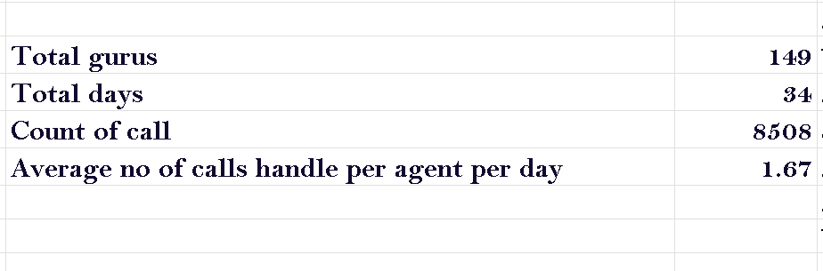

Question 8
How many repeat callers are there, and what percentage of total calls do they represent?

Solution:

Final Answer:
Repeat Callers = 6012
Total Call= 8365
Percentage of repeat call represents in total calls=56.63%

Approach:
Using pivot table user id in rows, values contain user id (count) and filter used the consultation type that is call.

Charts & Tables (if any):
Pivot Table refers to the excel sheet.

Question 9
What are the total sales generated by the call center for each product category?
Solution:

Final Answer:

Row Labels | Sum of netAmount
Call | 168442.035
Chat | 45494.68333
Public live  Call | 50.597

From pivot table we can the total sales generated by call from three product category. And from chart we can see the chart contain more percent in all the three products.

Approach:
Using pivot consultation type in rows and in values using sum of net amount.

Charts & Tables (if any):

Question 10
How many calls were made for each user ID and guru ID?

Solution:

Final Answer:
User ID and Guru ID calls were made are 8508.

Approach:
Using pivot approach user, guru and _id and count of uid and gid in values. And also using filter type consultation (call).

Question 11

Question:
What is the correlation between call duration and customer satisfaction?
Solution:

Final Answer:
0.480536
From this value we can say moderate positive relationship.

Approach:
Using simply correlation formula =CORREL(Cleaned_Data!V:V,Cleaned_Data!AM:AM)

Question 12
Which guru has the highest and lowest customer satisfaction scores?
Solution:

Final Answer:

Tarot Rittika | 0
Astro Pujaa Rai | 7.5

Approach:
Using pivot table guruname in rows and rating in values and determine the average for all the gurus. And by seeing a pivot table we can see the rating the lowest and highest.
Charts & Tables (if any):
Row Labels | Average of rating
Tarot Rittika | 0
Astro K Ojha | 0.102272727
Acharya Divyansh | 0.387387387
Astro Aditya | 0.794392523
Astro Sushil S | 0.851851852
Tarot Punam | 0.859477124
astro chandan | 1
Astro Yogendra | 1.006802721
Tarot Ittishri | 1.203821656
Tarot Keshmin | 1.235294118
Dr. Harish | 1.286419753
guru cool support | 1.4
Tarot Supriya Suri | 1.45045045
Astro R J S | 1.452229299
Astro Rohan S | 1.5
Astro Anil Shukla | 1.577777778
Astro sree valli | 1.626373626
Tarot Nipamani | 1.723404255
Astro Rajesh S | 1.798295455
Super Guru Ji | 1.819148936
Astro Mahesh S | 1.830508475
Astro Dr Ravindra | 1.846296296
Tarot Swati | 1.857142857
Tarot Neha R | 1.886075949
Astro Brejesh | 1.894392523
Tarot Raghavi | 1.925373134
Kaveshii Chauhaan | 1.953488372
Tarot Leena | 2.069767442
Usha Siingh | 2.15
Tarot Pooja | 2.181818182
Astro Naksh | 2.202614379
Astro Yashi | 2.333333333
Tarot Bee Riya | 2.36204576
Himanshu Pandey | 2.375
Tarot Riya | 2.416666667
Dr. Pratibha | 2.5
Astro Neetu | 2.505813953
Tarot Muskaan | 2.506329114
Acharya Dev | 2.516666667
Astro Sakthi | 2.537241379
Astro Rajiv B | 2.580645161
RAKESH KAUSHIK | 2.590909091
Dr Balkrishna | 2.593886463
Tarot Rushali | 2.6
Astro Vishwajeet | 2.683950617
Astro Krishna | 2.725
Tarot Akshay | 2.738636364
Astro Sanjeev | 2.74829932
Astro Akash | 2.75
Tarot Gargi | 2.765765766
Astro Dr Harish | 2.805555556
Tarot Seema | 2.836734694
Astro Ankita C | 2.846153846
Tarot Rupika | 2.846560847
Tarot Sunita | 2.861111111
Astro Uma Kant | 2.863192182
Astro Anaya | 2.875
Astro Sujata S | 2.895927602
Astro Gurdeep | 2.923076923
Tarot Kaashvi | 2.936507937
Tarot Shilpa P | 2.952380952
Astro Jha | 2.972677596
Tarot Ria | 2.984615385
Tarot preet | 3
Astro Aacharya Dev | 3
Dr. Balkrisna | 3.029850746
Tarot Barbiie | 3.090909091
Aachary Prateek | 3.109589041
Tarot SampritaP | 3.111111111
Tarot Aritra C | 3.14159292
Astro Aditya Jhha | 3.142857143
Tarot Gurpreet | 3.146
Tarot Aadhvik | 3.169934641
Astro Aditya | 3.216494845
Astro Mukesh | 3.222222222
Manorma Singh | 3.235294118
Astro Nisha | 3.275862069
Astro Krishaa | 3.330379747
Astro Anju | 3.333333333
Tarot Chanchal singh | 3.333333333
Astro Shweta | 3.334782609
Tarot Gauri | 3.388508892
Astro Seema | 3.398347107
Astro Deepti | 3.4
Astro Shalini | 3.417108251
Acharya Shastri | 3.428571429
Astro Prashant | 3.447368421
Dr. Shrey | 3.473684211
Tarot Surbi | 3.47826087
Astro Divya | 3.479166667
Tarot Shakti | 3.48
Astro Aabhishek | 3.486842105
Tarot Mamta D | 3.487603306
Astro Rhea | 3.5
Tarot Daljit | 3.511904762
Tarot Rachana | 3.549800797
Astro Aishwarya | 3.555555556
Astro Dr Shrey | 3.559322034
Tarot Harleen | 3.565217391
Tarot Rupanshi | 3.631578947
Tarot Gurpreet Kaur | 3.650641026
Astro Meena | 3.660818713
Tarot Bibhuti | 3.666666667
Astro Savita S | 3.689655172
Tarot Chanchal | 3.696428571
Astro Aditya N | 3.706484642
Astro Sonam S | 3.719414894
Tarot Yashita | 3.762711864
Astro Smarti M | 3.789473684
Tarot Ari | 3.854166667
Astro Jha Guruji | 3.869565217
Tarot Meera | 3.869565217
Astro preeti | 3.909090909
Tarot Priya S | 3.925
Tarot Monika | 4
Tarot Priyal | 4
Astro Pulkit S | 4
Tarot Anshu | 4
Acharya Arti S | 4
Tarot Vedika | 4.049342105
Tarot Esha | 4.117647059
Astro Lakshmi | 4.134920635
Astro Sukhdip | 4.146341463
Astro Ashok | 4.172859451
Shalini Sharma | 4.2
Astro Dr Balkrisna | 4.20657277
Astro Himanshu | 4.210526316
Astro SavitriDevi | 4.324324324
Gopi Vans | 4.333333333
Astro Manish SM | 4.352941176
Astro Ruchi | 4.442728443
Astro Niddhi Guptaa | 4.5
Astro Swami G | 4.652173913
Aham T | 4.785714286
Tarot Rhea | 4.822222222
Tarot Srishti | 4.87037037
Vandana Bhutani | 4.957746479
Tarrot Ria | 5
Swami Chandreshwaranand��G | 5
Astro Manish S | 5.048780488
Tarot Oormika | 5.4
Astro Trisha | 5.424324324
Tarot Diva Poonam | 5.462686567
Astro Saraswat | 5.611111111
Tarot Ankita | 5.75
Astro Reema | 5.9
Daljit Kaur | 5.945945946
Tarot Mystical | 7.5
Astro Pujaa Rai | 7.5
Grand Total | 2.93463446

- Description:
Table contains guru name and their average rating.

Question 13
What is the average customer satisfaction score by month?
Solution:
Final Answer:
Jan= 2.676
Dec= 2.949
Approach:
Using pivot table createdAT by months and in values average rating.
Charts & Tables:

Row Labels | Average of rating
Jan | 2.676413255
Dec | 2.949637572
Question 14

Question:
How many categorical columns are there in the data? [Search about categorical and continuous data, and try to answer this question]
Solution:

Final Answer:
Total= 23
Approach:
I manually counted the categorical columns.

_id
user
chatStatus
guru
guruName
consultationType
website
refundStatus
isWhiteListUser
queue
freeCall
freeChat
updatedAt
statementEntryId
chatStartTime
chatEndTime
callChannel
callIvrType
callStatus
CallSid
astrologerCallStatus
region

SUBJECTIVE QUESTIONS

Question 1
Should the investment be used to hire more agents, improve training programs, or upgrade call centre technology?

Solution:

Approach:
I have used the pivot table approach as it is easy to summarize the data and the problem for which we are looking.
Charts & Tables:
 | Row Labels |  |  | Count of _id
 | Call |  |  | 8508
 | Chat |  |  | 19514
 | Complementary |  |  | 2
 | public_live_Call |  |  | 3
 | Grand Total |  |  | 28027
Analysis Based on Average Rating per Guru
- Gurus with higher ratings (4+ stars) show better overall performance and can handle users more efficiently.
- Gurus with lower ratings (2–3 stars) may indicate service quality or communication issues.
Recommendation for Hiring More Agents
- Hire and scale agents who perform similarly to high-rated gurus.
- Avoid expanding low-performing profiles without proper training and improvement programs.
Improving Training Programs
(Using Average Call Time and Average Rating per Guru)
- Low ratings with long call durations suggest inefficient communication and problem-solving.
- Low ratings with short call durations may indicate poor service quality or incomplete support.
- High-rated gurus can be used as performance benchmarks for training programs.
Training Recommendations
- Provide communication and customer-handling training to low-performing gurus.
- Improve problem-solving efficiency through guided practice and mentoring.
- Use top-performing gurus as role models and training references.
Upgrading Call Center Technology
(Using Call vs Chat Distribution)
- Chat support accounts for nearly 70% of user interactions, while calls contribute around 30%.
- This indicates that most users prefer chat-based support over calls.
- The chat platform currently carries the majority of the operational workload.
Technology Upgrade Recommendations
- Invest more in chat infrastructure, including AI chat assistants and faster response systems.
- Improve server performance and scalability to handle increasing chat traffic efficiently.
- Continue optimizing the call system, but prioritize enhancements for the chat platform.

Question 2
What are the potential risks of each investment option (hiring, training, technology upgrades), and how can they be mitigated?
Name the chart/spreadsheet function you will use for solving the problem.

Solution:

Approach:
Hiring – Risk: Overstaffing / Understaffing
From this table we can analyse that hiring make the overstaffing because we can see there is overload on particular agents. There is no equal distribution of customers. In peak hours it gone resolve the problem of waiting of agents
Charts & Tables:
consultationType | Call
Row Labels | Count of _id
Aachary Prateek | 18
Acharya Arti S | 13
Acharya Dev | 39
Acharya Shastri | 7
Aham T | 21
Astro Aacharya Dev | 8
Astro Aditya N | 83
Astro Akash | 1
Astro Anaya | 4
Astro Anju | 6
Astro Ashok | 1
Astro Brejesh | 342
Astro Dr Shrey | 177
Astro Jha | 148
Astro Lakshmi | 71
Astro Manish SM | 2
Astro Meena | 48
Astro Mukesh | 5
Astro Naksh | 32
Astro Niddhi Guptaa | 2
Astro Prashant | 36
Astro preeti | 11
Astro Ruchi | 238
Astro Sakthi | 152
Astro Sanjeev | 126
Astro Shweta | 226
Astro Sujata S | 140
Astro Sushil S | 2
Astro Trisha | 1
Astro Uma Kant | 102
Astro Vishwajeet | 91
Astro Yogendra | 30
Astro Aabhishek | 76
Astro Aditya | 53
Astro Aditya Jhha | 7
Astro Aishwarya | 18
Astro Anil Shukla | 12
Astro Ankita C | 2
astro chandan | 7
Astro Deepti | 5
Astro Divya | 271
Astro Dr Balkrisna | 111
Astro Dr Harish | 22
Astro Dr Ravindra | 30
Astro Jha Guruji | 23
Astro Krishaa | 114
Astro Krishna | 258
Astro Mahesh S | 9
Astro Neetu | 88
Astro Nisha | 29
Astro Pulkit S | 5
Astro Rajesh S | 157
Astro Rajiv B | 108
Astro Rhea | 9
Astro Roha S | 1
Astro Savita S | 28
Astro SavitriDevi | 9
Astro Seema | 191
Astro Shalini | 1060
Astro Smarti M | 4
Astro Sonam S | 213
Astro sree valli | 35
Astro Sukhdip | 8
Astro Swami G | 17
Daljit Kaur | 9
Dr Balkrisna | 309
Dr. Pratibha | 2
Dr. Balkrisna | 29
Dr. Harish | 112
Dr. Shrey | 95
Gopi Vans | 5
Himanshu Pandey | 6
Kaveshii Chauhaan | 17
Manorma Singh | 75
RAKESH KAUSHIK | 18
Shalini Sharma | 5
Super Guru Ji | 44
Tarot Aadhvik | 5
Tarot Ankita | 1
Tarot Anshu | 2
Tarot Ari | 152
Tarot Aritra C | 50
Tarot Barbiie | 11
Tarot Bibhuti | 6
Tarot Gurpreet | 300
Tarot Ittishri | 7
Tarot Kaashvi | 38
Tarot Muskaan | 50
Tarot Neha R | 2
Tarot Oormika | 1
Tarot preet | 53
Tarot Priya S | 1
Tarot Punam | 18
Tarot Rupanshi | 19
Tarot Rushali | 5
Tarot SampritaP | 9
Tarot Seema | 233
Tarot Shilpa P | 3
Tarot Sunita | 22
Tarot Supriya Suri | 35
Tarot Yashita | 15
Tarot Akshay | 72
Tarot Bee Riya | 278
Tarot Chanchal | 56
Tarot Chanchal singh | 27
Tarot Daljit | 19
Tarot Esha | 28
Tarot Gargi | 76
Tarot Gauri | 497
Tarot Gurpreet Kaur | 24
Tarot Harleen | 19
Tarot Keshmin | 6
Tarot Leena | 3
Tarot Mamta D | 12
Tarot Monika | 5
Tarot Nipamani | 8
Tarot Pooja | 2
Tarot Rachana | 44
Tarot Raghavi | 10
Tarot Rhea | 8
Tarot Ria | 19
Tarot Riya | 1
Tarot Rupika | 225
Tarot Srishti | 10
Tarot Surbi | 22
Tarot Swati | 13
Tarrot Ria | 1
Usha Siingh | 96
Insights:
Mitigation (from Pivot result):
Redistribute calls
Hire only if all agents are overloaded
Training – Risk: Training not improving performance
There is always a risk in hiring new agents because they required the training first and we can't predict the performance of them.
What we can we can train the underload working agent and assign them at peak hours.
Mitigation: Continue training only where improvement is visible

Recommendations:
Investment in technology can be risky because there will be the problem for adoption for the new technologies. Implementing new technologies can when required more time to train the agents and money also. What we can do we can implement the technologies in percentage while improving the services side by side and tracking it monthly.

Question 3
How does Astro Sage’s call centre performance compare to Astro Guru’s average call volume, customer satisfaction, and agent performance?
Will you use any aggregation function or a visualization here to solve the problem?
Solution:

Approach:
We can use reference benchmarking for comparison using Astro sage overall average.
Using pivot table, here we are using average aggregate function and count function. And chart type we are using clustered bar.
Astro Sage’s metrics act as reference values for comparing Astro Guru’s future performance.
Charts & Tables:
- Description:
Table Month and Count of calls.

- Description:
The chart defines the name of gurus and their average rating.
- Description:
The above table defines the call status and count of call done by the agents.

Insights:
We calculated the average 4254 call volume of two operational months.
Using the pivot refer in excel with guru names and average rating we got the max rating are 7.5 and min 0.
And with another table we calculated
The percentage of customer issues that are resolved successfully in the very first call, without needing a callback or repeat call.
Called first call resolution that is (completed calls / Total calls)/100 = 40.55.

Recommendations:
I would recommend are average should need improvement. And also, customer satisfaction needs to be improved as ratings are not above 8.5 and there should be no 0 rating for the agent and with zero, they need to be trained proper. And first call resolution needs to be near to looked immediately as are total completed are less and why there is no answer by the agents.

Question 4
How can the call centre improve its handling of peak call periods to ensure high customer satisfaction?
Mention the functionality you will use for giving the suggestions, will it be any aggregated function or a visualization?

Solution:

Approach:
I have used the pivot table to get the peak call periods and how the rating is affected during that time.

Charts & Tables:
consultationType | Call
Row Labels | Count of uid | Average of rating
0 | 69 | 3.463768116
1 | 52 | 3.326923077
10 | 605 | 3.571900826
11 | 515 | 3.446601942
12 | 483 | 3.49689441
13 | 437 | 3.556064073
14 | 513 | 3.49122807
15 | 497 | 3.61167002
16 | 479 | 3.528183716
17 | 374 | 3.430481283
18 | 264 | 3.378787879
19 | 222 | 3.545045045
2 | 129 | 3.379844961
20 | 172 | 3.5
21 | 103 | 3.398058252
22 | 126 | 3.5
23 | 157 | 3.401273885
3 | 264 | 3.522727273
4 | 348 | 3.640804598
5 | 449 | 3.467706013
6 | 541 | 3.452865065
7 | 551 | 3.508166969
8 | 660 | 3.459090909
9 | 498 | 3.526104418

- Description:
The above table represents the time in hours which 24 hours format and the peak call during that time and how the customer satisfaction rating is varied.

Insights:
By seeing at table, we found around 8vAM there is peak time for the calls. And rating is 3.4. The pivot table gives the better insights as compared to charts.

Recommendations:
In order to maintain high customer satisfaction, it is advised to increase manpower during peak hours, optimise call routing, reduce average handling time through training, and introduce self-service support alternatives. I will say pivot table, count and average use as a aggregate function.

Question 5
Based on historical data, what strategic initiatives should be prioritized to improve efficiency and customer satisfaction?
Solution:
Approach:
Using previous pivot able and aggregation function.
Insights:
Historical data was analyzed using aggregation functions such as COUNT and AVERAGE through Pivot
Tables to identify trends in call volume, customer satisfaction, and agent performance.
From our previous analysis (call volume by hour and average rating by hour), we observed that:
Certain hours have very high call volume (peak periods).
During these peak periods, average customer ratings drop.
Some agents have higher performance than others.
Late-night and peak hours have lower satisfaction.
These insights come from:
COUNT (Call ID) → call
volume
AVERAGE(Rating) → customer satisfaction
Pivot Tables by Hour and Agent
Recommendations:
Optimizing the Workforce (Staffing Strategy)
During peak hours, increase the number of agents.
Make use of flexible shift scheduling
Demand forecasting based on past patterns
Enhances: pleasure and waiting time.

Performance Management & Agent Training
Give underperforming agents training.
Distribute top-performing agents' best practices.
Concentrate on problem-solving training during peak hours.
Enhances: First Call Resolution

Question 6
What can be the key factors contributing to high customer satisfaction scores, and how can these be leveraged to improve overall performance?
What is the basis for the suggestions? And mention how you decided if the satisfaction score affects the ratings.
Solution:

Approach:
Analysing pivot tables
1. Key Factors Contributing to High Customer Satisfaction Scores
a) Lower Call Volume / Non-Peak Hours
b) High Agent Performance
c) Faster Resolution (Lower Handling Time)
d) Higher First Call Resolution (Completed Calls)

Charts & Tables:
- Basis for the Suggestions (What analysis you used)
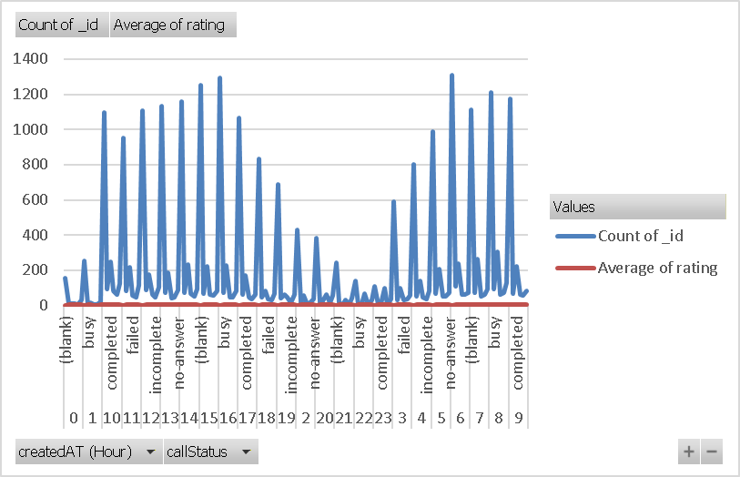
We analysed that if call volume increases at peak hours the ratings are decreasing. And those calls are getting completed getting average rating.

Insights:
- How you decided that satisfaction score affects ratings.
Using correlation analysis.
=CORREL (C9:C175, D9:D175), -0.35784
A moderately negative link was indicated by the correlation study between call volume and customer satisfaction score, which yielded a value of -0.35. This implies that customer satisfaction tends to decrease at times of high call volume, most likely as a result of lengthier handling or waiting times and an increased workload.

Recommendations:
- How these factors can be leveraged to improve performance
Copy the strategies of high-performing agents
Use best practices to instruct others.
Cut down on wait times to increase customer satisfaction.
Priorities First Call Resolution.
Cut down on unfinished and unsuccessful calls.

Question 7
How should the call center balance the workload among agents to ensure optimal performance and avoid burnout?
Mention your approach and spreadsheet function for the answer.
Solution:
Approach:
Workload per agent
From this table we can how many calls handled by the agents
We found that there is no equal distribution for the agents and increasing workload on a particular agent.
Identified overload and underloaded agents
We found that the red one highlighted agent is overload and with green one highlighted are underload.

Charts & Tables:
For tables, please refer to excel spreadsheet name subjective question 7
Insights:
Compare Workload with Performance (Quality Check)
By pivot we can see the agents with high workload, their rating is low and their performance is lagging due to burnout risk.
Recommendations:
So, to avoid burnout risk and increase performance we can hire a new agent also we can assign the agents to peak hours with underload work. And also assign the agents at alternative calls with overload agents to cut down their workload. With this we can enhanced the performance also.

Question 8
What new technologies or tools could be implemented to enhance call centre operations and customer service?
Solution:

Recommendations:
AI Chatbots & Virtual Assistants – Automate routine customer queries and reduce call volume, saving manpower costs and improving response time.
Cloud-Based Contact Center System (CCaaS) – Provides scalability, remote working capability, high reliability, and lower infrastructure and maintenance costs.
CRM Integration (Smart Customer Database) – Gives agents instant access to customer history, improving personalization and increasing First Call Resolution (FCR).
Speech Analytics & AI Quality Monitoring – Analyzes calls for customer sentiment and agent performance, helping improve service quality and targeted training.
Workforce Management & Predictive Analytics Tools – Optimizes agent scheduling, forecasts call volume, and reduces waiting time and operational inefficiencies.

Question 9
What metrics should be included in the final dashboard to comprehensively view call centre performance and guide investment decisions?

Solution:
Recommendations:

Call Volume (Total Calls Handled)
Shows demand
Helps decide staffing, shifts, and technology investment
Monthly Call Volume Growth
Whether demand is increasing or decreasing
Helps justify future staffing or automation
Customer Satisfaction Score (CSAT)
Direct measure of customer experience
Used to link service quality to retention
Sum of net Amount
Measure the amount of sales generated by services.
Question 10
How would you allocate a 1 crore rupee investment to optimize operational efficiency, enhance customer satisfaction, and boost profitability, and what analysis-based recommendations would you offer to support this?
[you have to give bullet pointers to answer this question]
Solution:

Approach:

Investment Allocation of ₹1 Crore
- ₹40 Lakhs – Technology Upgrades
  - Implement CRM software, call routing automation, and AI chatbots.
  - Upgrade data analytics tools for real-time monitoring of performance (Average Handling Time, First Call Resolution, Average Customer Satisfaction Score).
  - Improve infrastructure (faster systems, better connectivity).
- ₹35 Lakhs – Employee Training & Development
  - Customer handling & communication skill training.
  - Technical issue resolution training to improve First Call Resolution (FCR).
  - Leadership and productivity training for supervisors.
- ₹25 Lakhs – Hiring & Workforce Optimization
  - Hire skilled agents to reduce call load per employee.
  - Add quality assurance and customer experience specialists.
  - Reduce overtime and employee burnout.

Insights:
Technology improves speed and accuracy.
Training improves service quality and FCR.
Hiring improves workload balance and reduces errors.
Combined approach ensures sustainable growth.

Recommendations:
- Data Analysis on Call Volume
  - Identify peak call hours and allocate staff accordingly.
  - Reduce customer waiting time and abandonment rate.
- First Call Resolution (FCR) Analysis
  - Focus training on problem categories with low FCR.
  - Improves customer satisfaction and reduces repeat calls.
- Average Handling Time (AHT) Analysis
  - Use automation and scripts to reduce unnecessary call duration.
  - Balance speed with quality service.
- Customer Satisfaction (CSAT) Analysis
  - Monitor agent-wise and issue-wise CSAT scores.
  - Reward high performers and retrain low performers.
- Cost-Benefit Analysis
  - Compare investment cost vs operational savings from automation and reduced manpower dependency.
  - Prioritize high-ROI technology solutions.

